CS 340 Project Two – Dashboard Application
Hilnecia Larry

Project Overview
This project involved developing a full-stack dashboard application using Python, Dash, and MongoDB. The purpose of the dashboard is to allow users to interact with animal shelter data and identify dogs suitable for different types of rescue training, such as water rescue, wilderness rescue, and disaster tracking.

The application connects to a MongoDB database using a previously developed CRUD Python module. The dashboard provides a user-friendly interface that allows filtering of data, visualization through charts, and mapping of animal locations.

Functionality of the Dashboard
The dashboard includes several key features:
- An interactive data table that displays animal shelter data retrieved from MongoDB
- Radio button filters that allow users to filter dogs based on rescue type:
  - Water Rescue
  - Mountain/Wilderness Rescue
  - Disaster/Tracking
  - Reset (returns to unfiltered data)
- A geolocation map that updates based on the selected row in the data table
- A pie chart visualization that shows the distribution of dog breeds

These components work together to provide an interactive and intuitive user experience.

Tools and Technologies Used
The following tools were used to develop the application:
- MongoDB – Used as the database to store animal shelter data
- PyMongo (via CRUD Python module) – Used to interact with MongoDB
- Python – Main programming language for the application
- Dash (Plotly) – Used to build the web-based dashboard interface
- Dash Leaflet – Used to create the geolocation map
- Pandas – Used for data manipulation and transformation

MongoDB was chosen because it allows flexible storage of JSON-like data, which is ideal for handling structured but variable datasets like animal records. Dash was used because it allows rapid development of interactive dashboards using Python.

Steps Taken to Complete the Project
- Developed a CRUD Python module in Project One to connect to MongoDB
- Created an unfiltered interactive data table to display all animal data
- Implemented filtering functionality using radio buttons
- Connected filters to MongoDB queries through the CRUD module
- Built a geolocation map that updates based on table selection
- Created a pie chart to visualize breed distribution
- Added the Grazioso Salvare logo and a unique identifier (name)
- Tested the dashboard to ensure all components updated correctly
- Captured screenshots to demonstrate functionality

Challenges and Solutions
One challenge encountered was ensuring that the dashboard components updated correctly when filters were applied. This required properly linking Dash callbacks to both the data table and the visual components.

Another challenge was handling the MongoDB _id field, which caused errors in the data table. This issue was resolved by removing the _id column from the dataset before displaying it.

Overall, careful debugging and testing ensured that all components worked as expected.

Default Dashboard (Unfiltered)
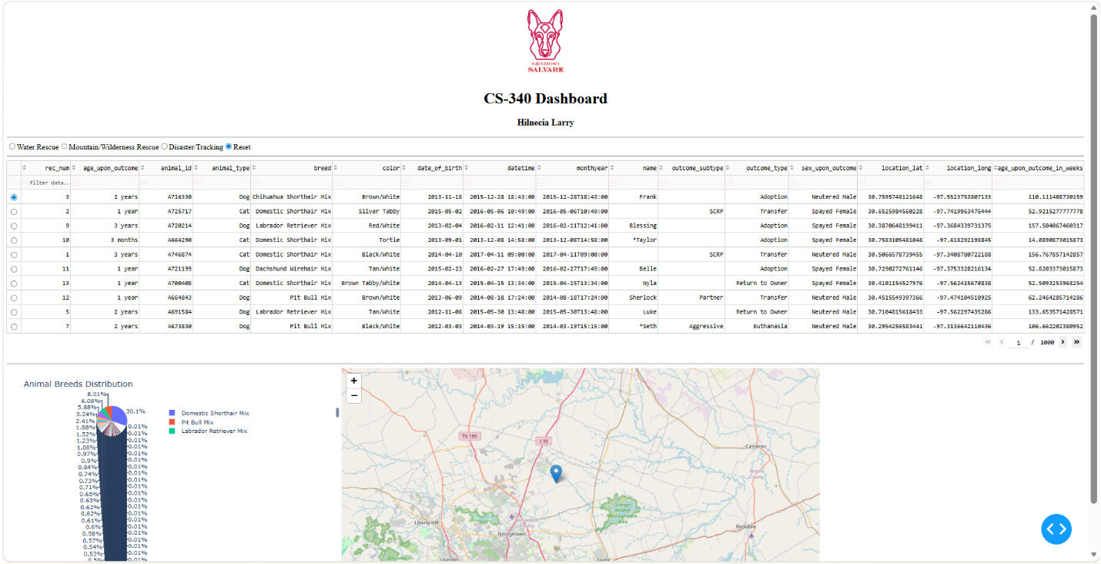

Water Rescue Filter Applied
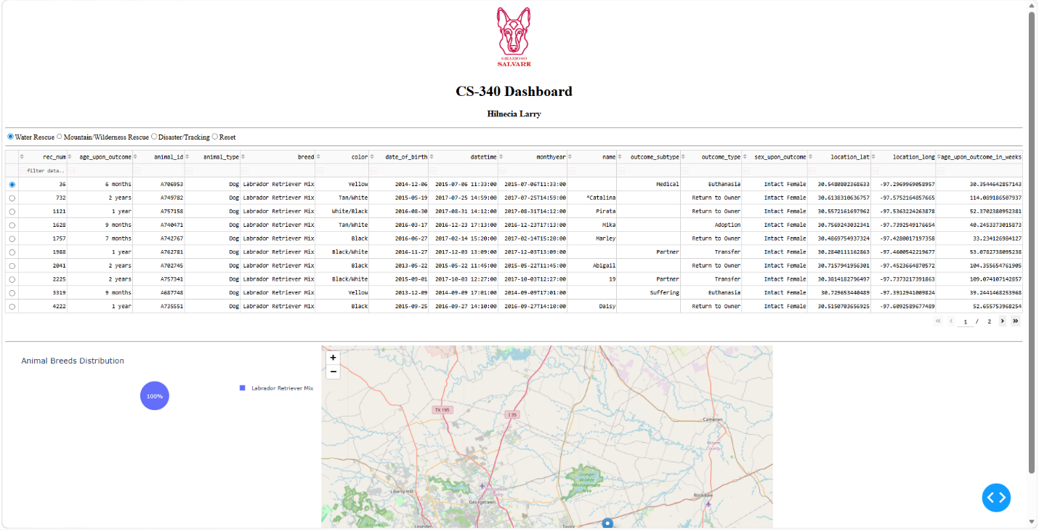

Mountain/Wilderness Rescue Filter Applied
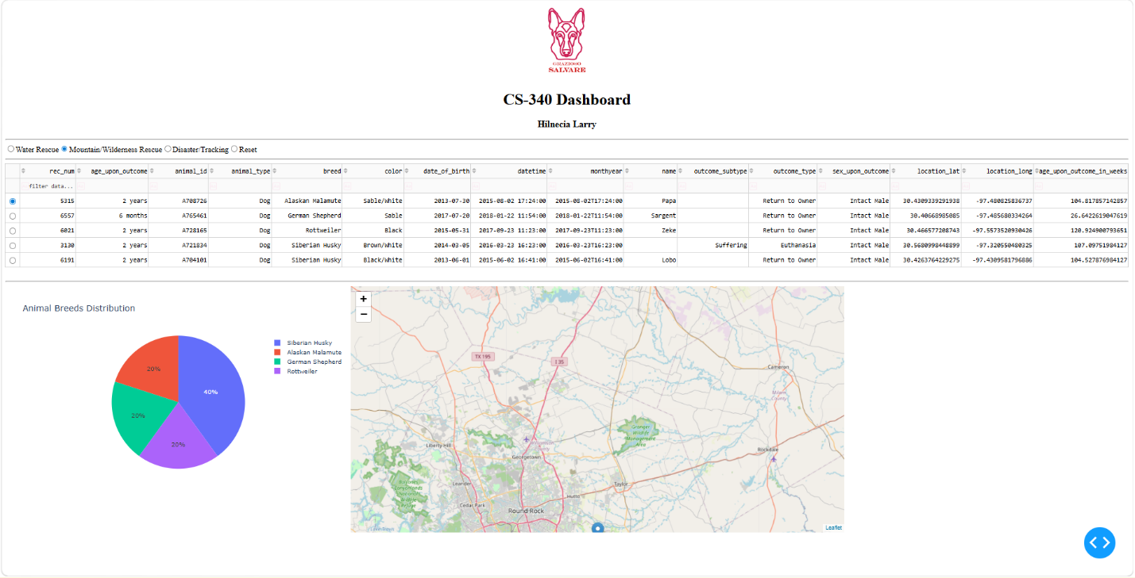

Disaster/Tracking Filter Applied
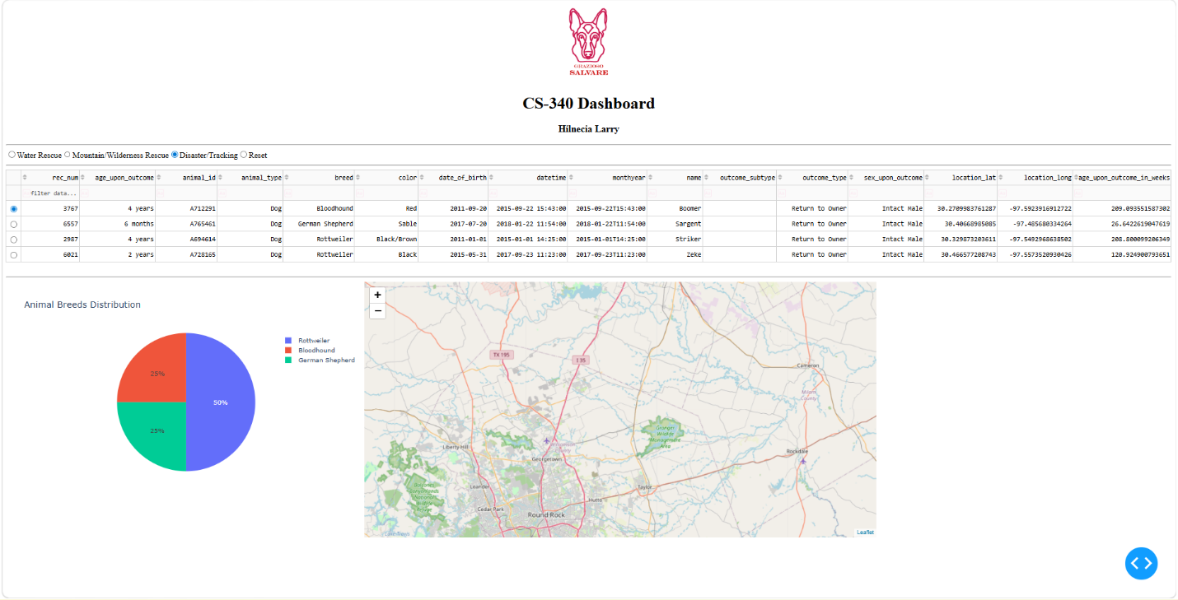

Reset to Default View
